**Figure 1. Question 1**

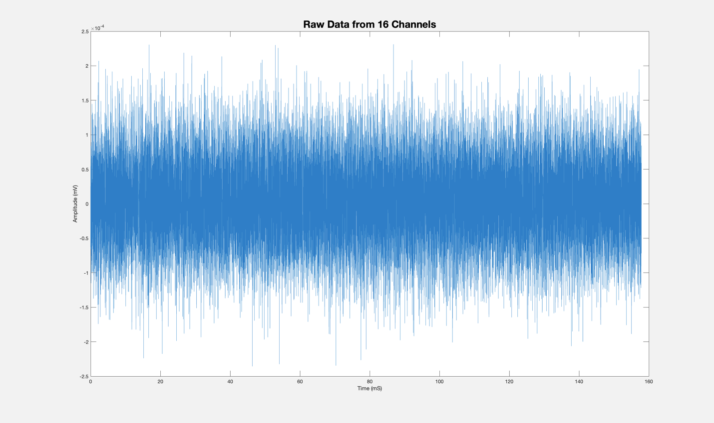

**Figure 1.** Raw data from 16 channels is shown in Figure 1. The data is plotted as waveforms measured in Amplitude on the y axis(mV) and Time on the x axis (ms). The data is visually evoked data from visual cortex of rats. Each of the 16 channels is in visual cortex with Channel 1 closest to the surface and channel 16 deepest in cortex.

**FIGURE 2. Question 1**

**Figure 1.** *Raw data from 16 channels is shown in Figure 2. The data is plotted as waveforms measured in Amplitude on the y axis(mV) and Time on the x axis (ms) We can see the difference between Raw Data (top), and spike filtered data (middle). This is was then compared to the time of each visual stimuli. The Visual Stimuli shows us each stimuli shown to the subjects lasts approximately 1 second. The data is visually evoked data from visual cortex of rats. Each of the 16 channels is in visual cortex with Channel 1 closest to the surface and channel 16 deepest in cortex.*

**Question 3**

**Figure 3.** *The above figure demonstrates raster plots for each of the 16 channels. These figures show the “spikes” over 2 seconds. There is .5 seconds from prior to when the subject is shown the visual stimuli (time -.5 to 0 seconds). Then, the time subjects were shown a visual stimulus corresponds to times 0 seconds to 1 seconds. This is followed by a .5 second “rest” period. The raster corresponds to spikes in the data.*

**Question 4.**

**Figure 4***. Figure 4 demonstrates the respective PSTH for each of the channels 1- 16. Each of the 16 channels is labeled with the corresponding Channel number. The y axis is measures Intensity of the signal and the x axis measures time. Each of the time bins here starts 5 seconds before the visual stimulus and ends 1.5 seconds after. Channel 1 is closest to the surface of the visual cortex, and each subsequent channel is deeper in cortex. It appears later channels have less correspondence to stimulus evoked from visual stimuli, as they show many spikes, including before 0 seconds, the time before the subject was shown a visual stimuli.*

**Question 5.**

**Figure 5***. Figure 3 demonstrates the respective mean PSTH for each of the channels 1- 16. Each of the 16 channels is labeled with the corresponding Channel number. The y axis is measures Intensity of the signal and the x axis measures time. Each of the time bins here starts 5 seconds before the visual stimulus and ends 1.5 seconds after. Channel 1 is closest to the surface of the visual cortex, and each subsequent channel is deeper in cortex. It appears as though later channels have less correspondence to stimulus evoked from visual stimuli, as they show many spikes.*

**Question 6.**

**Figure 6.** *This figure above demonstrates average spike rate change for each channel. Channel 1 is closest to the surface of the visual cortex, and each channel is subsequently located deeper in visual cortex.*

**Accompanying questions:**

7.What are the three main cell types present in the brain? Which of these cells are electrically excitable? Which of these cells change their membrane potential? How are these cells different?

There are many different types of cells in the brain. There are two broad classes of cells in the brain: neuronal cells and glial cells. Within the brain, there are three main cell types including: neurons, glial Cells (including astrocyte and microglial), and myelinating cells (Schwann/Oligodendrocytes). Neurons, primary unit of the nervous system, are electrically excitable and communicate to other cells via electrical impulses. They have their membrane potentials to fire action potentials in response to a variety of stimuli including synaptic inputs, sensory information. They communicate with one another using neurotransmitters and hormone signaling molecules. Astrocytes and Microglia don’t generate action potentials and are not electrically excitable in the same way as neurons are. Their membrane potential changes are usually not part of electrical signaling. Astrocytes perform a variety of functions to support the nervous system like maintaining ion balances in the extracellular space, making sure blood flow is regulated in the brain, and other metabolic support for neurons. Microglia respond to injury and play a role in defense and inflammation in the brain. Myelinating cells like Schwann Cells (peripheral nervous system) and oligodendrocytes (central nervous stem) aren’t electrically excitable like neurons are. They have membrane potentials that don’t contribute to electrical signaling. Schwann cells myelinate allowing for rapid conduction of action potentials and oligodendrocytes enhance conduction of electrical signals. The myelin serves as insulation which can improve how fast and how efficient electrical signals can propagate in the brain.

8.How can you separate synaptic potentials from action potentials in intra-cellular recordings? What are common filter ranges to isolate synaptic potentials? What are common filter ranges to isolate action potentials?

After recording intra-cellular signal, filtering is an essential step to isolating different components of the intra-cellular recording. When filtering, filter ranges are chosen to target specific frequency bands associated with synaptic potentials versus action potentials. There is high-pass filtering (for action potentials) that removes low-frequency components (mainly include synaptic potentials and slow voltage). Specifically, filter settings for action potentials might range from 0.1 Hz to 1 kHz, depending on the specific characteristics of the signals and your research goals. The exact value depends on the quality of signal and the method by which the signal was collected (ie patch clamp vs whole cell, etc). On the other hand, low-Pass filters can be used for synaptic potentials which would remove high-frequency noise. These might range from 1 kHz to 10 kHz. The exact value will depend on the specific recording and the specific parameters that are of interest for synaptic events/

9. How would you implement a PSTH for electrophysiology data that does not have an evoked stimulus? You can think about ways that only employ the data available, or you can think about a complementary recording that may be available.

A PSTH is a great way to study the firing patterns of neurons. The dataset explored in Assignment IV was visually evoked and had neurons fire in response to a certain visual stimulus. Using PSTH involves creation of time bins. This means that once created, firing rate could be measured for any time that an experimenter has chosen. However, when there’s no evoked stimulus you could use this method and it might provide information on spontaneous neuronal firing (not stimulated). To do this, you would need to chose when you would want to begin examination of data and chose a “starting point” for example maybe when you started your recording session or you would be looking for a specific point at which an event is occurring and then you’d need to make time bins of regular, fixed durations which would serve to divide up the recorded data (could be different sizes if you needed this), then you would measure the firing rate by literally counting the spikes in the bins, and then you could perform many types of analysis to look for patterns or examine the data closer. You could compare this data to another data set (for example, a healthy person if looking at a person with potential disease or a brain of some subject not subjected to certain stimuli) to gain valuable information.